Math 1 Name ______________________________

**6-2 Parallel Lines with Algebra 1** Date________

* *I can define and apply important geometric terms.*

In the following problems, . Write the vocabulary word(s) that describe the two angles mentioned in the problem. Then solve for the variable and find the measure of the unknown angle(s).

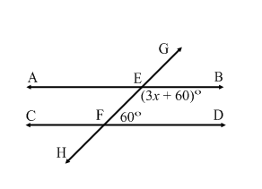

1.

2. 

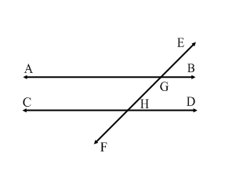

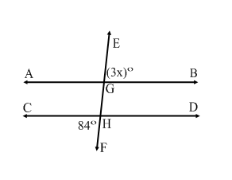

3.

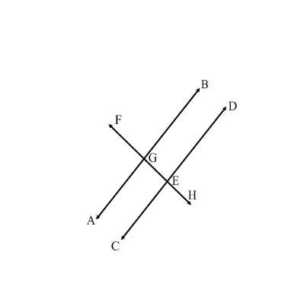4. 

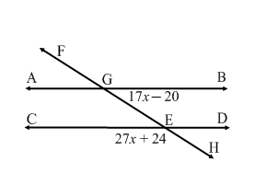5.

6. 

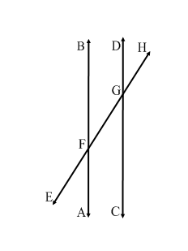

7. 

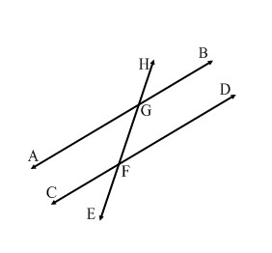

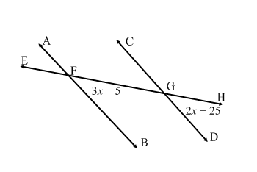8.

9. 

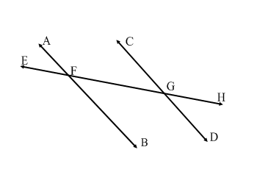

10. 

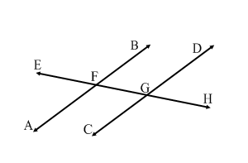

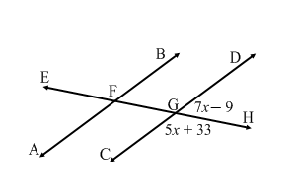11.

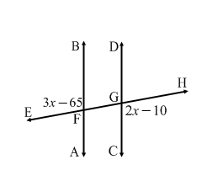12.